**Q 5**   
Write a Python program using the Turtle graphics library to plot the graph of the function $y=x^{2}$ for values of $x$ ranging from -10 to 10. Your program should follow these steps:

1. **Set up the coordinate system:**
   * Configure the Turtle screen to represent a Cartesian plane, with the origin (0, 0) at the center of the window.
   * The x-axis should range from -10 to 10, and the y-axis should range from 0 to 100.
2. **Draw the axes:**
   * Draw the x-axis and y-axis with labeled tick marks at intervals of 1.
3. **Plot the function $y=x^{2}$:**
   * For each integer value of $x$ from -10 to 10, calculate $y=x^{2}$ and plot the corresponding point using the Turtle pen.
   * Connect the points with lines to create a smooth curve.
4. **Enhance the graph:**
   * Use different colors for the curve, axes, and tick marks.
   * Add labels for the x-axis, y-axis, and the function $y=x^{2}$.

**Example Output:**

The graph should display a parabolic curve representing the function $y=x^{2}$**:**, centered on the Cartesian plane.

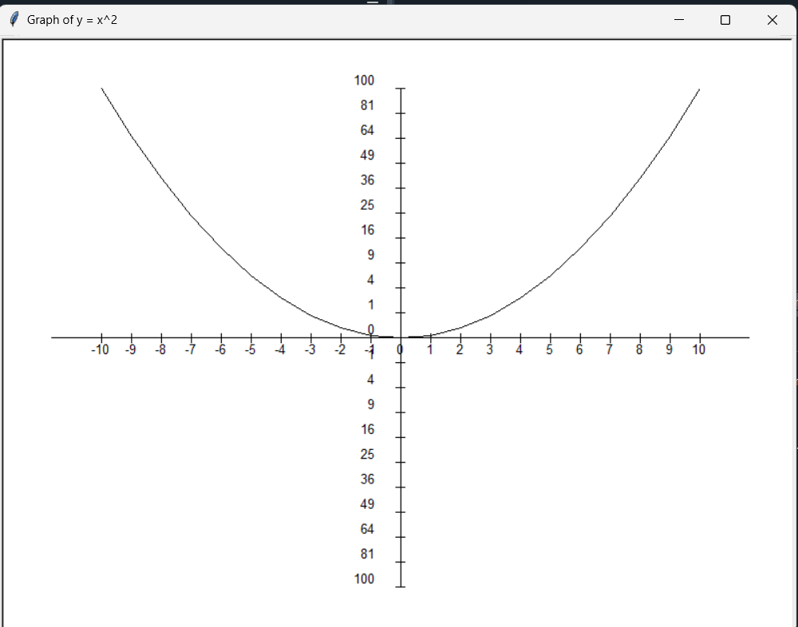

### Grading Rubric (Out of 10 Points):

|  |  |  |
| --- | --- | --- |
| **Criteria** | **Points** | **Description** |
| **Coordinate System Setup** | 2 | The coordinate system is correctly set up, and the screen is centered at (0, 0). |
| **Axis Drawing** | 2 | The x-axis and y-axis are drawn accurately with labeled tick marks. |
| **Function Plotting** | 3 | The function $y=x^{2}$ is correctly plotted, and points are connected to form a smooth curve. |
| **Graph Aesthetics** | 2 | The graph is visually appealing, with appropriate use of colors, line thickness, and labels. |
| **Code Clarity and Comments** | 1 | The code is well-structured, easy to read, and includes comments explaining key sections. |